Burgers & Sandwiches
Served with Fries or Tater Tots. Substitute Onion Rings for $2 more
Build Your Own Burger*....$10.95 + add ons
1/3-pound Burger grilled to your liking on a Kaiser Roll with choice of cheese. Add toppings to satisfy your taste buds!
Godfather Sandwich.......$12.95
Homemade Italian Sausage patty served on Garlic Bread with Mozzarella Cheese and Marinara Sauce.
Hot Ham & Cheddar........$11.95
Toasted Texas Toast layered with Grilled Ham Slices and melted Cheddar Cheese.
Shrimp Po’Boy............$14.95
4 Panko Breaded Shrimp with Lettuce, Tomato and Homemade Spicy Tartar on toasted French Bread
Add Ons
Cheddar, American, Swiss, Pepperjack, Provolone or Mozzarella
2pc Bacon $3.95 • Sautéed Mushrooms $1.95
2 Onion Rings $1.75 • Coleslaw $.50
Tomato $.50 • Extra Burger Patty $5.95
Soup of the Day
Ask your server for soup of the day flavors
Cup $3.95 Bowl $4.95 To Go $5.25
*Consuming raw or undercooked meats, poultry, seafood, shellfish, or eggs may increase your risk of foodborne illness, especially if you have certain medical conditions.

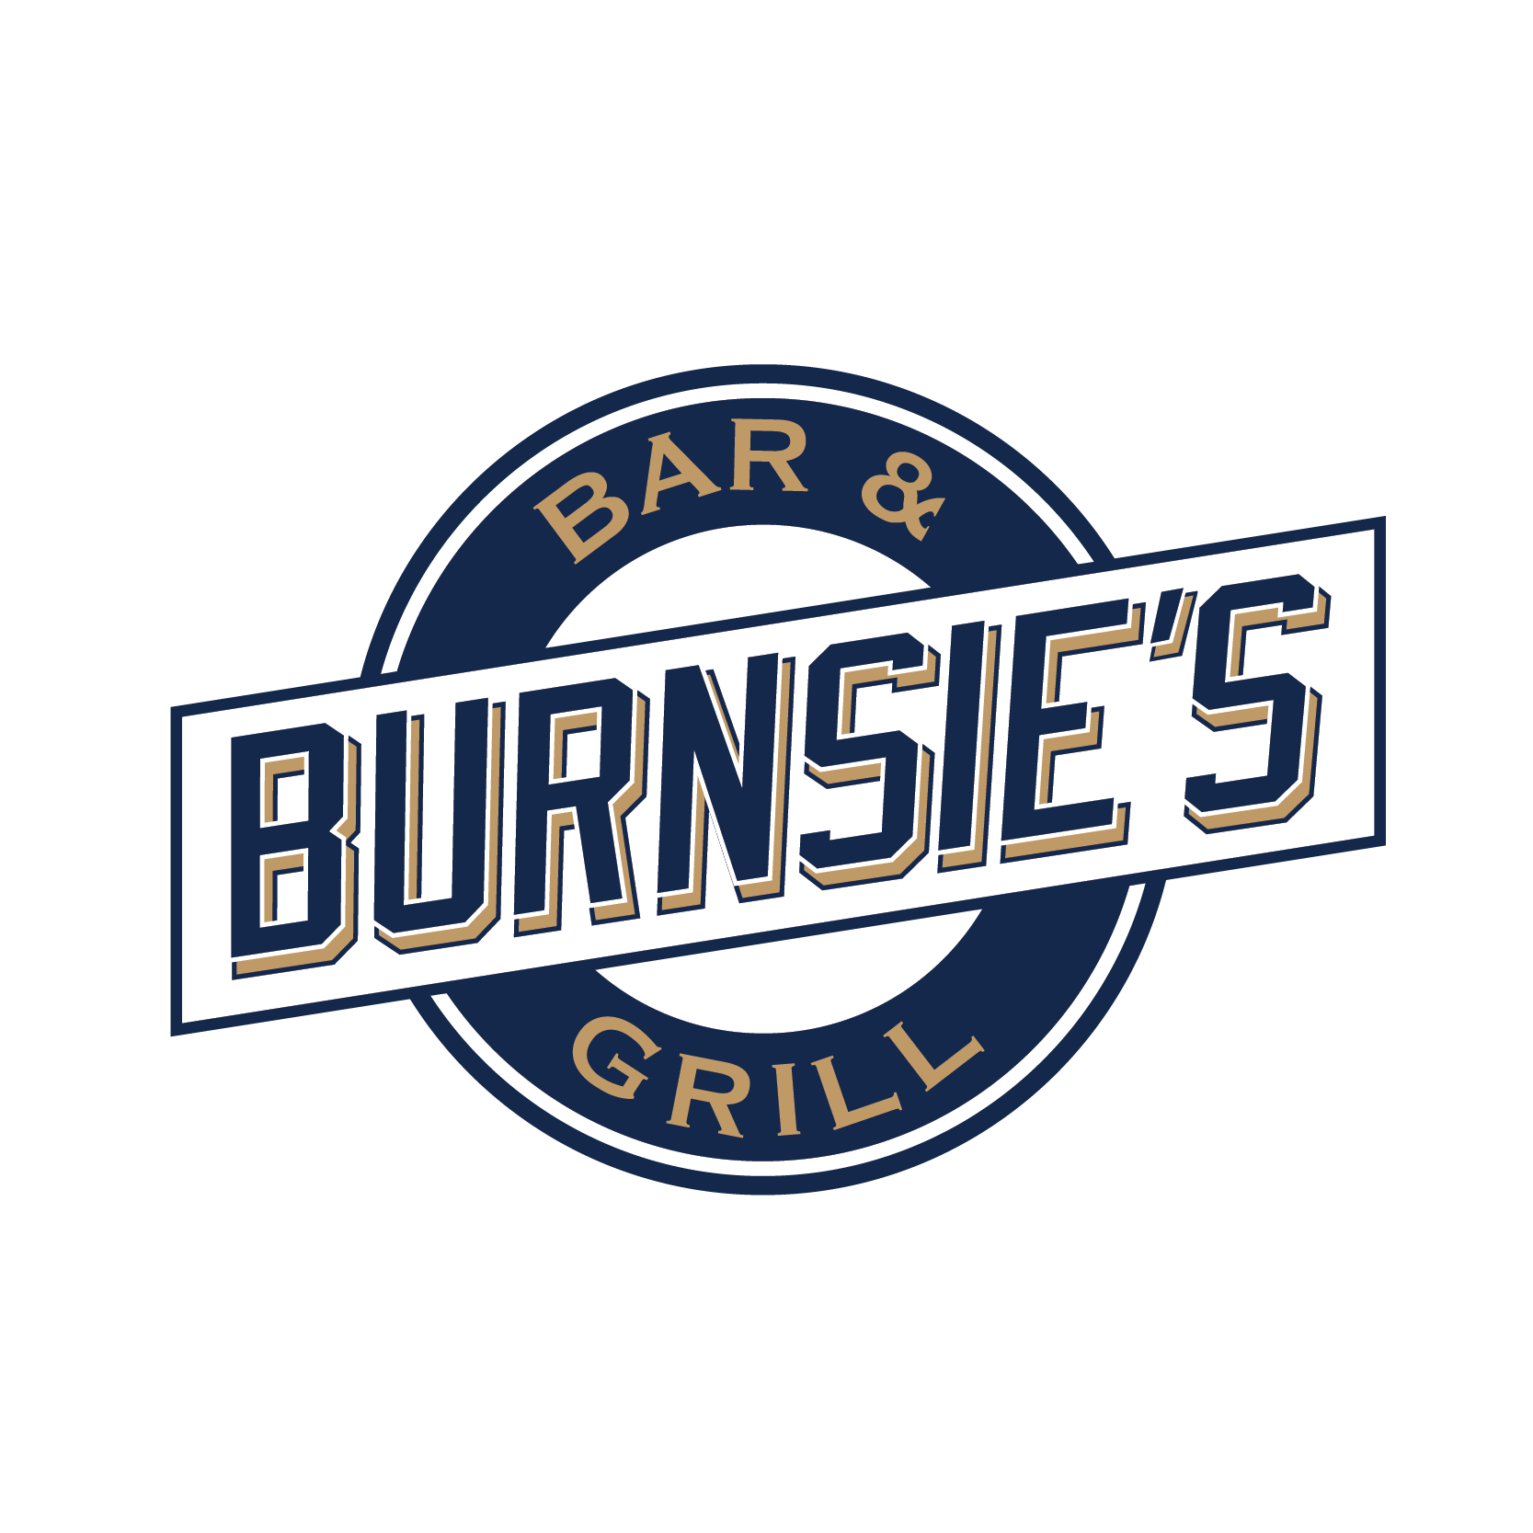
9646 W Greenfield Ave.
West Allis, WI
(414)258-0888

Starters
WI Cheese Curds.........$8.95
Real Breaded Wisconsin Cheese Curds w/ Ranch
Broccoli Cheddar Bites..$8.95
Blend of Cheddar, Broccoli and a hint of Bacon w/ Ranch
Breaded Mushrooms.......$8.95
Lightly breaded Button Mushrooms w/ Ranch
Fried Pickle Chips......$8.95
Lightly breaded Dill Pickle Chips w/ Ranch
Jalapeño Poppers........$9.95
Spice of Jalapeno & the Cool of Cream Cheese w/ Ranch
Irish Reuben Rolls......$11.95
Handmade rolls served with Housemade Thousand Island
Burnsie’s Famous Artichoke Dip....$11.95
Homemade Artichoke Dip served with toasted French Bread
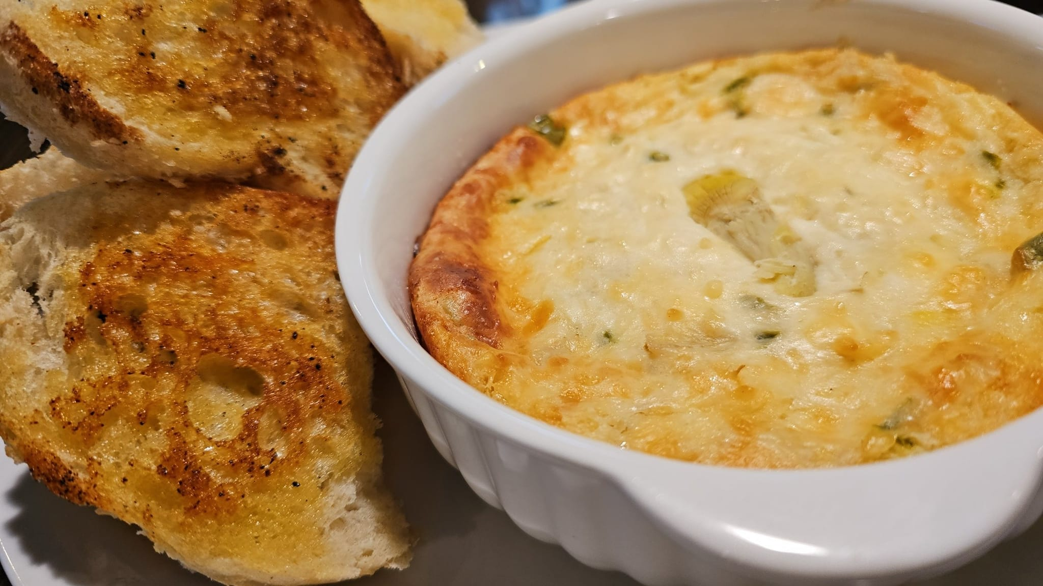
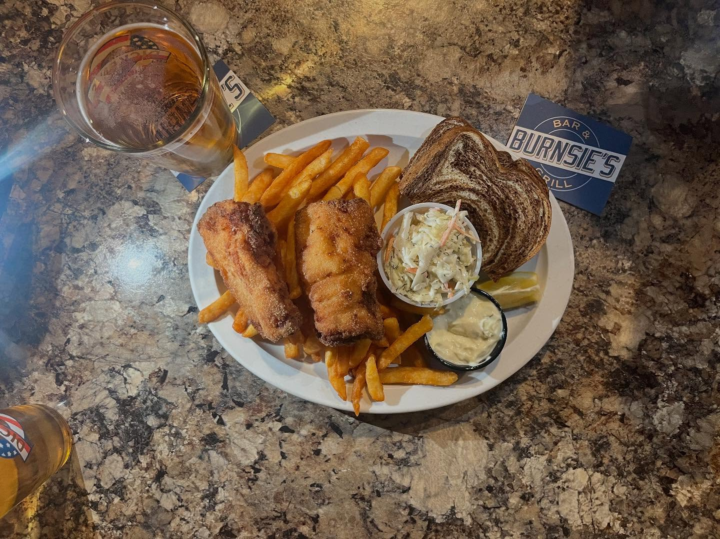
Friday Fish Fry
Served all day Friday until 9pm. All dinners include Coleslaw, Rye Bread and Fries, Tater Tots or Potato Pancakes. Substitute Onion Rings for $2 more.

Classic Cod...........$13.95
Two 4oz, hand-breaded Cod Loins with Housemade Tartar
½ Order Cod...........$9.95
Our Classic Cod with only one 4oz Cod Loin
Shrimp Dinner.........$14.95
8 Panko Breaded Butterfly Shrimp w/ Cocktail Sauce
Breaded Lake Perch....$16.95
8oz of hand-breaded Lake Perch w/ Housemade Tartar
Pan-Fried Walleye.....$17.95
Lightly floured, pan-fried Walleye fillet w/ Housemade Tartar. LIMITED WEEKLY SUPPLY, SERVED AFTER 4:00pm

